# Wildlife Conservation CRM — Phase 2: Org Setup & Configuration

**Project:** Wildlife Conservation CRM

**Short description:** A Salesforce-based CRM to manage wildlife sightings, rescues, donations, volunteers, events, and conservation campaigns. This Phase 2 document contains step-by-step org setup and configuration instructions, ready-to-fill screenshots, and validation checks for your project submission.

## 2.1 Salesforce Edition & Environment

**Purpose:** Ensure the org supports metadata, Apex, Flows, and Lightning development.

**Steps:**

1. Go to Setup and enter **Company Information** in Quick Find, then select **Company Information**.
2. Check or fill the following:
   1. **Organization Edition:** Developer (for learning) or Enterprise (with sandbox)
   2. **Instance:** Copy the instance ID (e.g., NA45)
   3. **Purpose:** Development or Testing

**Doc snippet:**  
*"Edition: Developer Edition — supports Apex, Flows, and Lightning development."*

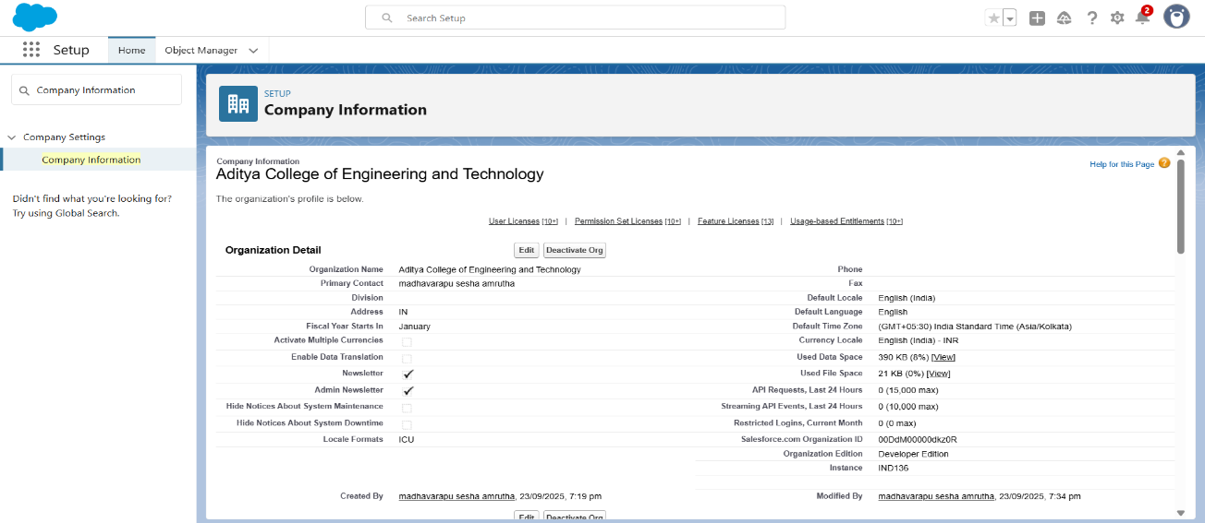

## 2.2 Company Profile Configuration

**Purpose:** Align org defaults (locale, timezone, currency) with NGO operations.

**Steps:**

1. Go to Setup and enter **Company Information** in Quick Find, then click **Edit**.
2. Fill the following values:
   * Organization Name: Wildlife Conservation Trust
   * Industry: Nonprofit / Environmental Services
   * Default Locale: English (India)
   * Default Language: English
   * Default Time Zone: (GMT+05:30) India Standard Time
   * Default Currency: INR (₹)

**Validation:** Create a Donation record and verify currency and date format.  
**Doc snippet:**  
*"Organization Name: Wildlife Conservation Trust — Locale and currency set to India (INR) for donation reporting."*

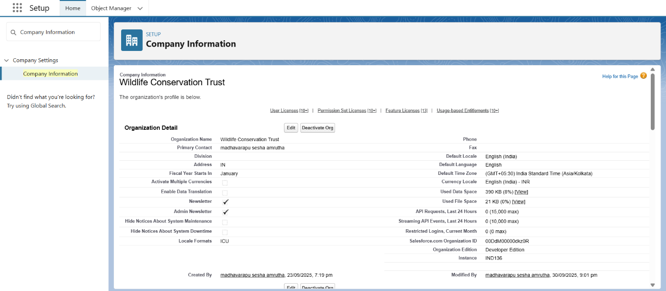

## 2.3 Business Hours & Holidays

**Purpose:** Align volunteer/event scheduling with office hours; respect holidays.

**Steps:**  
**Business Hours:**

1. Go to Setup and enter **Business Hours** in Quick Find, then click **New**.
2. Fill the following values:
   * Name: Wildlife Standard Hours
   * Time Zone: GMT+05:30
   * Working Days: Monday to Saturday, 09:00 to 18:00

**Holidays:**

1. Go to Setup and enter **Holidays** in Quick Find, then click **New**.
2. Add major NGO holidays such as World Wildlife Day, Earth Day, Founder’s Day.

**Validation:** Schedule a Flow or timed action and confirm it respects business hours.  
**Doc snippet:**  
*"Business Hours: Monday to Saturday 09:00–18:00; major NGO holidays added to avoid auto-scheduling."*

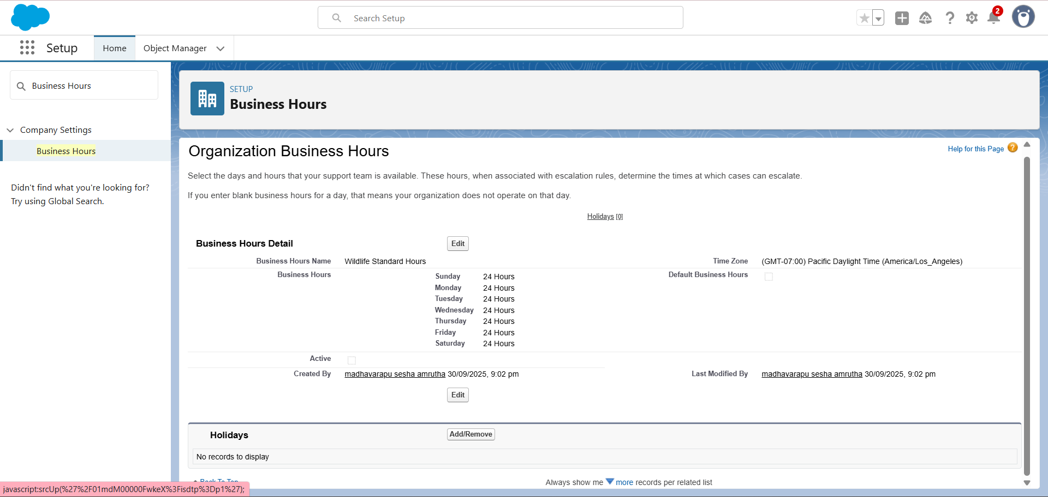

## 2.4 Fiscal Year Settings

**Purpose:** Group donations and budgets by fiscal year.

**Steps:**

1. Go to Setup and enter **Fiscal Year** in Quick Find, then select **Fiscal Year**.
2. Choose **Standard Fiscal Year** and set Start Month to April.

**Validation:** Run a donation report grouped by fiscal year.  
**Doc snippet:**  
*"Fiscal Year: Standard (April–March) to align with local statutory accounting cycles."*

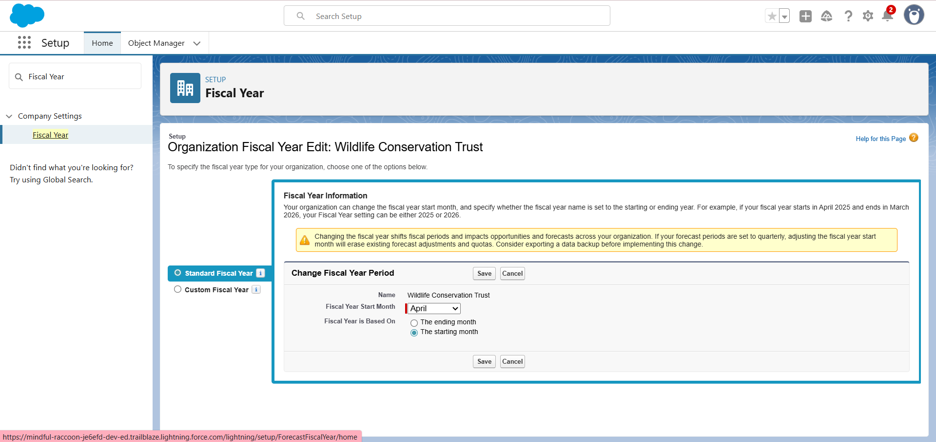

## 2.5 Role Hierarchy, Profiles, Permission Sets & Users

**Purpose:** Define access rules and user capabilities.

**Roles:**

1. Go to Setup and enter **Roles** in Quick Find, then click **Role Hierarchy** and set up roles.
2. Recommended roles: Executive Director, CRM Admin, Fundraising Manager, Volunteer Coordinator, Field Officer, Veterinarian.

**Profiles:**

1. Go to Setup and enter **Profiles** in Quick Find.
2. Clone standard profiles to create: Wildlife_Admin, Fundraising_Manager_Profile, Volunteer_Coordinator_Profile, Field_Officer_Profile.

**Permission Sets:**

1. Go to Setup and enter **Permission Sets** in Quick Find, then click **New**.
2. Create permission sets: Fundraising_Manager_PS, Volunteer_Coordinator_PS, Field_Officer_PS.

**Users:**

1. Go to Setup and enter **Users** in Quick Find, then click **New User**.
2. Sample user: Priya Singh, Username: priya.wildlife@example.com, Role: Fundraising Manager, Profile: Fundraising_Manager_Profile.

**Validation:** Login as test user and verify creating Donation, Volunteer Assignment, and running reports.  
**Doc snippet:**  
*"Roles, profiles, and permission sets configured to separate fundraising, volunteer coordination, and field operations."*

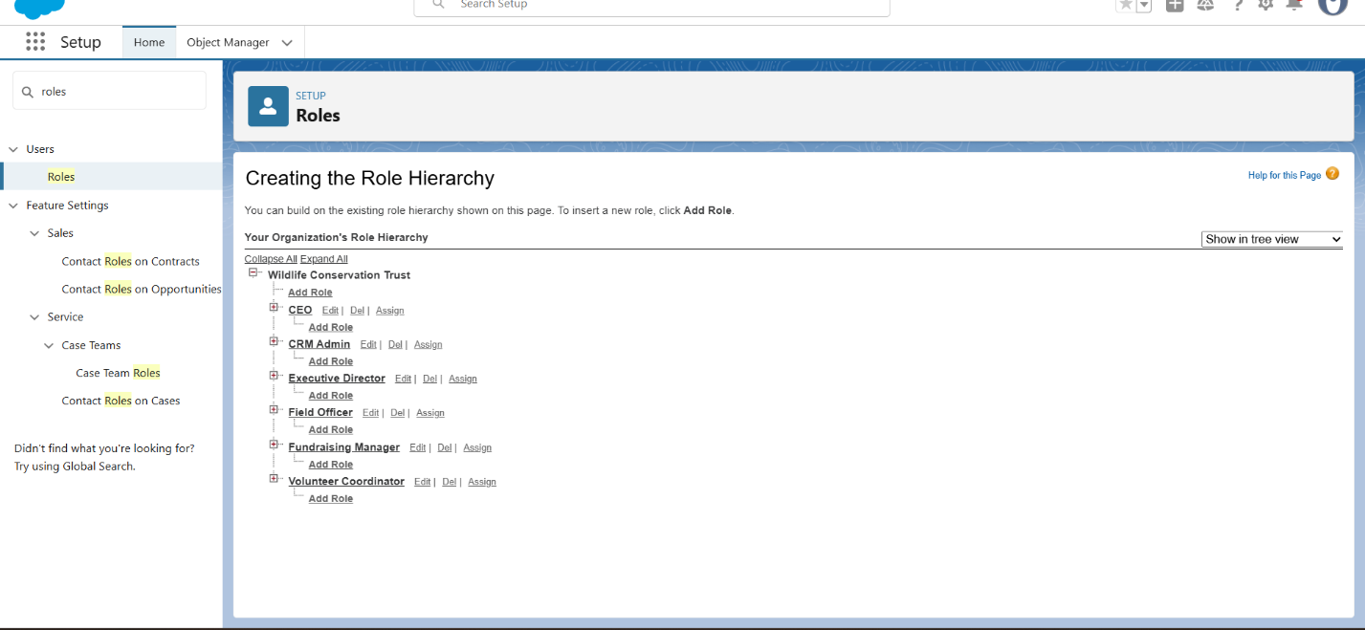

## 2.6 Login Access Policies & Security Basics

**Purpose:** Secure troubleshooting, session management, and login restrictions.

**Steps:**

1. Go to Setup and enter **Login Access Policies** in Quick Find, then configure.
2. Go to Setup and enter **Session Settings** in Quick Find and set session timeout.
3. Update **Login IP Ranges** in Profiles if access restriction is needed.

**Recommended:** Allow Admin login-as-user in development orgs.  
**Validation:** Admin can login as test user or request access grant.

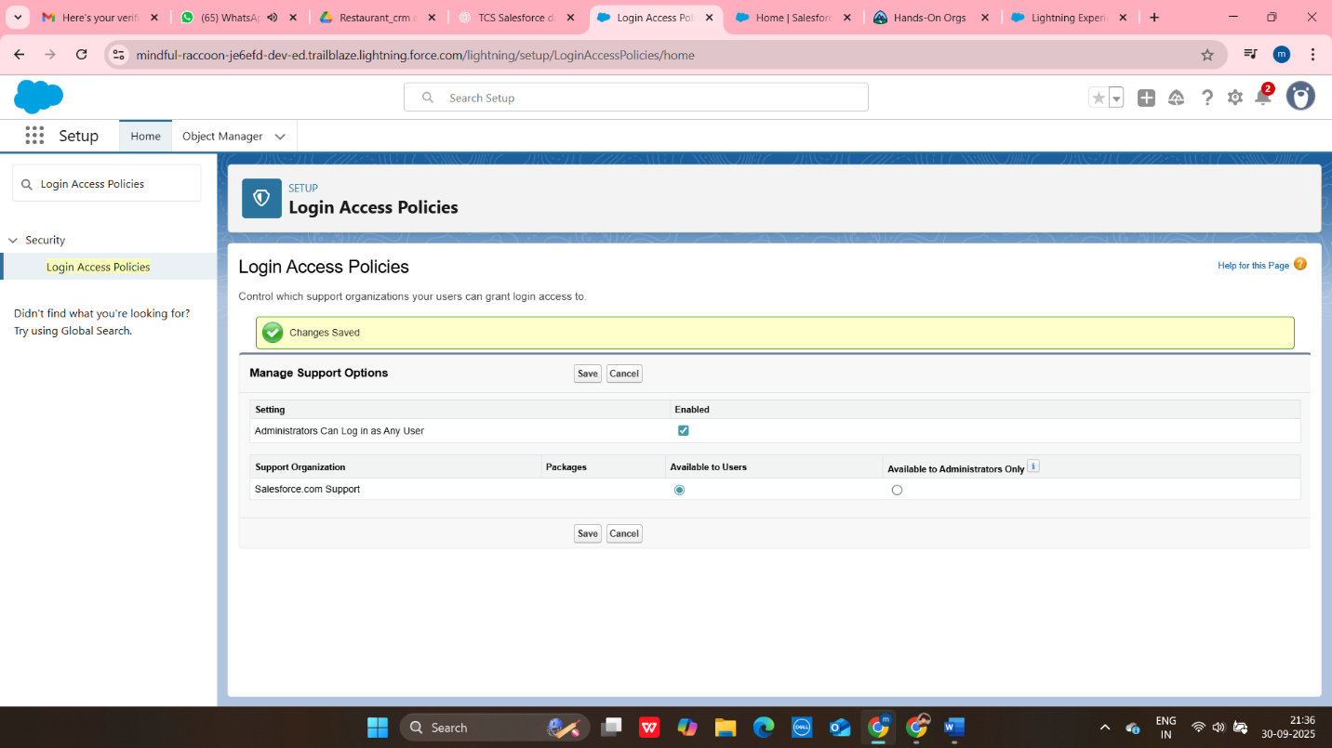

## 2.7 Developer Tools & Org Preferences

**Purpose:** Prepare for source-driven development and testing.

**Steps:**

1. Enable Dev Hub if using scratch orgs.
2. Install Salesforce CLI and VS Code (document versions used).
3. Go to Setup and enter **Email Deliverability**, then set to All Email for testing.
4. Go to Setup and enter **App Manager**, edit Lightning App → Branding → upload logo.
5. **Validation:** Send test email via Flow or Email Alert and confirm delivery. Confirm SFDX source retrieval.

